8.73: Let v be the speed of the mass released at the rim just before it strikes the second mass. Let each object have mass m.
Conservation of energy says 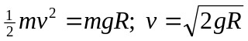
This is speed for the collision. Let 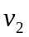be the speed of the combined object just after the collision. Conservation of momentum applied to the collision gives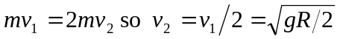

Apply conservation of energy to the motion of the combined object after the collision.
Let 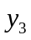be the final height above the bottom of the bowl.

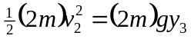

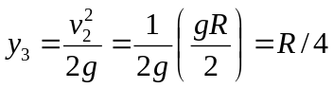
Mechanical energy is lost in the collision, so the final gravitational potential energy is less than the initial gravitational potential energy.

